Summer 2022
POWERFUL TIMES
Gabriela’s selfpower

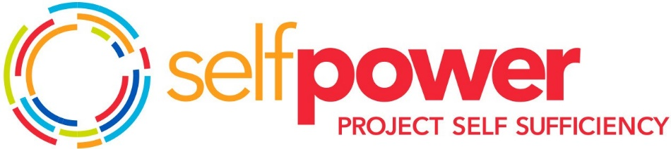

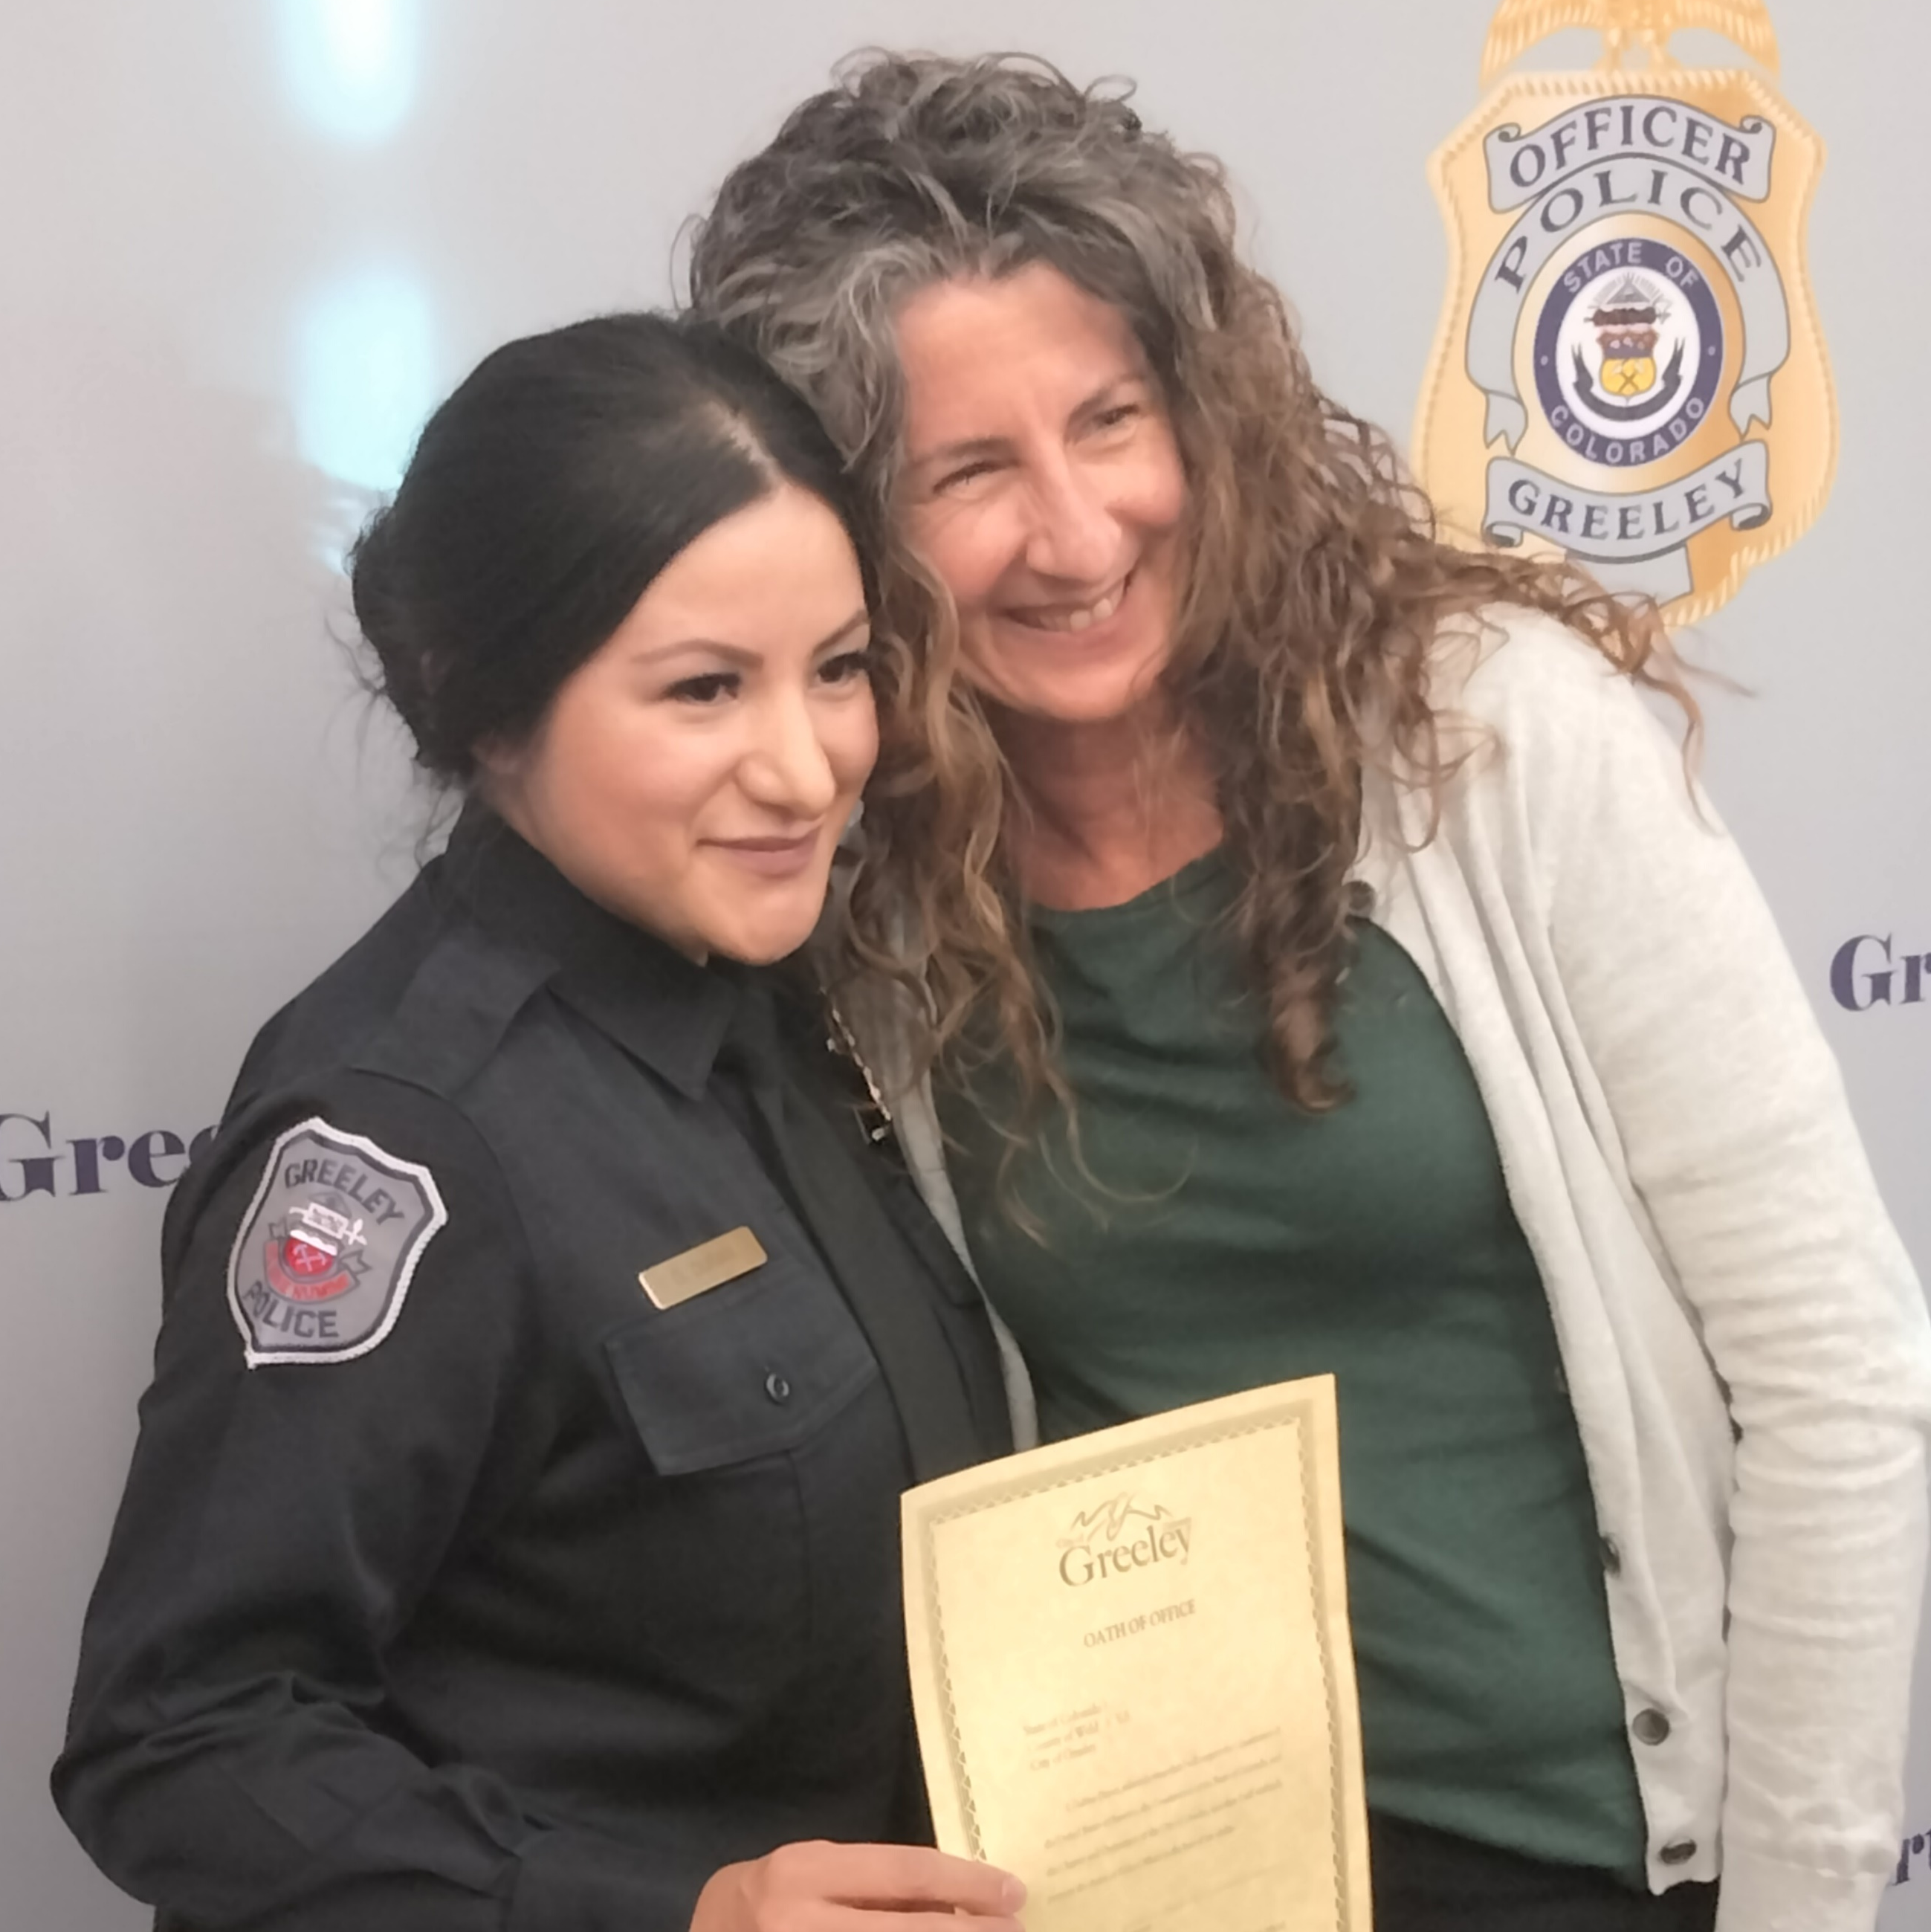

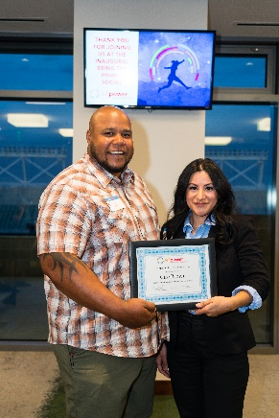
Gabriela joined our program in April of 2017. She had been at her Certified Nursing Assistant (CNA) job at Columbine for six years and began taking classes at Front Range Community College (FRCC) to eventually earn a degree as an American Sign Language (ASL) interpreter. She was determined to pursue a meaningful career and be a powerful example to her daughter, Carla. Her goal was to create economic stability and opportunity for her future, but she was unsure if she was on the right track.
Gabriela at the 2022 Bring the Power Social with the recipient of her named scholarship, Cire.
During her career exploration stage, Gabriela discovered there were typically only a couple of part-time jobs available locally for ASL interpreters and that they paid less than her CNA
job, she grew worried and decided to

bringthepower.org

pause on that educational path to determine a new direction.
Gabriela returned to FRCC to pursue
an Associate's degree in Criminal Justice, confident in this new direction. While working and attending school part-time, she also participated in ride-along observations and attended the FCPD Civilian Academy. Even though this was a heavy load,
Gabriela was aligned with a sense of purpose and joy in what she was doing.

Project Self Sufficiency helped Gabriela pursue every opportunity by giving her additional resources for her daughter, such as Cool Kids funds for back-to school clothing, under-the-tree gifts and food boxes from the Holiday Fund, and for herself educational scholarships that offset living expenses, as Gabriela earned her degree.
Gabriela’s Advisor, Nicole, shared that during her time in the program, Gabriela was always the first to turn in scholarship applications and complete tasks.
“She radiated with the joy of learning and developing her mind and future.”

Before she finished her training, Gabriela applied for jobs with the Colorado State University and Fort Collins Police Departments. Preparation for this required an incredible amount of additional time and effort, especially for a single mother who works and attends school. Nicole shared that throughout
the process,

Gabriela had a “growth mindset that allowed her to learn and refine and speak more confidently rather than becoming discouraged”.

Gabriela completed her AA in Criminal Justice in May 2020.
Her progress to this achievement was not without setbacks and disappointments. After earning her degree, her plan was to complete Police Officer Standards Training (POST) at Aims Community College. Gabriela applied but was not accepted. She was disappointed, but she applied to the next closest POST Program at Red Rocks Community College in Lakewood and was quickly admitted.
After completing POST Academy, it only took a few months for Gabriela to be hired full-time by the Greeley Police Department. They valued her diverse life experience and continued education, making her a strong candidate. Not only did she gain employment in her chosen
career field, but she also increased her income by over $50,000 a year.
“Gabriela has consistently set an example of being all in”, said Nicole. This year, as a successful Program Graduate, she spoke at our Bring the Power Social fundraiser to our donors and supporters. Project Self-Sufficiency honored an up-and-coming Program Participant, Cire, who is pursuing his educational goals in Criminal Justice, with a scholarship in Gabriela’s name. Congratulations Gabriela on all of your amazing accomplishments and we wish you the best in your career!

Right Size Giving provides a platform for businesses to maximize their social impact and community exposure at the same time. Businesses sign up and give once each year, with recognition and benefits provided throughout the year, based on their “Power Level”, or level of investment. Our Right Size Giving Partners are dedicated to our community and the important work we do because they know that every investment in Project Self-Sufficiency:
- Is an investment in human capita; education and training create a qualified workface that is essential to business growth and success;
- Perpetuates a positive cycle in our community; educated and employable families become self-reliant, thrive, and are able to participate fully in all this community has to offer;
- Changes the course for multiple generations; education and career become the norm and not the exception. We see our children pursue the same level, or more, of education as their parent.
For information on becoming a Right Size Giving Partner contact Daniela at 970-829-5316 or daniela@bringthepower.org
Project Self-Sufficiency Welcomes Our 2022 Right Size Giving Business Partners

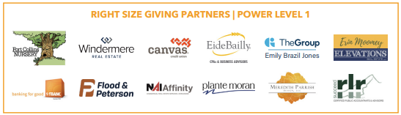

DEVELOPMENT DIRECTOR CORNER

Hello!

My name is Daniela Morzos, and I am the new Development Director for Project Self-Sufficiency. I came on board in January and am delighted to be a part of this long standing and reputable organization. My email is daniela@bringthepower.org and my phone number is 970-829-5316. I invite you to reach out with questions about Project Self-Sufficiency, volunteering, or donating.

Warmly,
Daniela Morzos

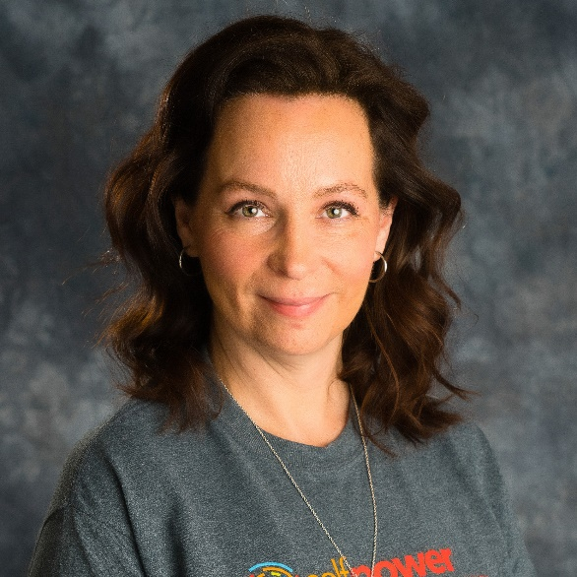
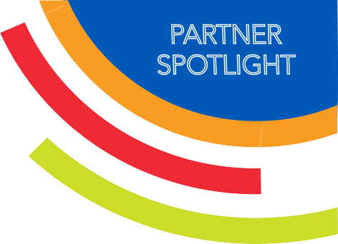
PARTNER SPOTLIGHT
Realities for Children Charity

Realities For Children (RFC) was incorporated in 1995 and has been funding the unmet needs of Larimer County children who have been abused, neglected, or are at-risk since 1996. RFC also educates Northern Colorado businesses on children’s issues and spreads awareness of their partner agencies, like Project Self-Sufficiency, who are working to meet those needs in the community.
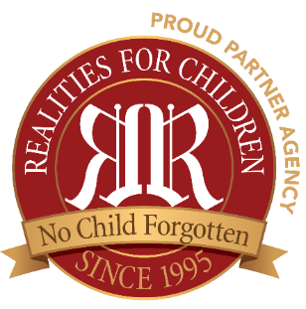
Funds are granted to Project Self-Sufficiency annually and as needs arise during the year, approval for fund distribution can be made within 60 minutes. Project Self-Sufficiency determines the need for emergency funding on a case-by-case basis when all other resources have been exhausted or are unavailable.
RFC has been an event sponsor for many years, helping us underwrite the cost of our fundraisers, thereby increasing the amount of funds raised that directly benefit our single-parent families. In addition, they also support the Back-to-School Backpack program for our Participant’s children.
Project Self Sufficiency is proud to be a collaborative partner with Realities For Children.

RFC also coordinates free monthly events for the children of Project Self-Sufficiency Participants, like birthday parties at Loveland Laser Tag, trampoline parties, roller skating, swimming, and free tickets to local sporting events and theater experiences, which many families can’t afford on their own.

Cars For Families Program: Donate Your Car Today!

Transportation is essential for Participants enrolled in Project Self-Sufficiency, as they take steps to increase education, gain work experience, and accomplish personal goals. Single parents need reliable and safe transportation to get to school and work, get their children to school and appointments, and do basic errands. For most families, relying on public transportation or borrowing a vehicle is unsustainable. The Cars for Families Program provides donated cars and funds for car repairs to keep Participants driving toward their educational and career goals, while building and maintaining strong and healthy families.
“I was grateful that I was donated a vehicle by Project Self-Sufficiency! This allowed me to be more flexible with my appointments and allowed me to come and go as I pleased. Having a vehicle also relieved stress that was from scheduling and having to ask for transportation. Now I can schedule appointments that work best for my kids and myself, I have been able to intern in a different town and be able to go do things with my kids for fun.” - Brook
“When I got the donated vehicle, it helped me out a lot. I was able to continue schooling appointments, get my kids to and from school, and doctor's appointments.” -Tosha
“I was grateful that I was donated a vehicle by Project Self-Sufficiency! This allowed me to be more flexible with my appointments and allowed me to come and go as I pleased. Having a vehicle also relieved stress that was from scheduling and having to ask for transportation. Now I can schedule appointments that work best for my kids and myself, I have been able to intern in a different town and be able to go do things with my kids for fun.” - Brook
Don’t Miss Your Chance to Win a New Camping Trailer!
Don’t Miss Your Chance to Win a New Camping Trailer!
None of our donated vehicles are sold at auction, which is important to maximize your tax deduction with the fair market value of the vehicle. We can provide all of the paperwork and make it easy for you. For more information, email natasia@bringthepower.org or visit our website to fill out the Cars for Families Vehicle Donation Form to begin the process.
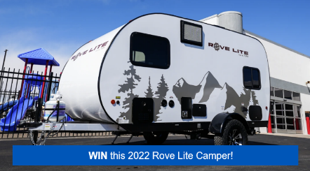
Enter to win a new Ultra Lightweight Camping Trailer by Travel Lite RV! The Rove Lite is a perfect option for anyone wanting to explore the outdoors with function and style. Donate to Project Self-Sufficiency and support single-parent families as they reach their education and career goals to be entered into this sweepstakes. Just donate through this link and you will automatically be entered into the drawing! Sweepstakes end August 19th.
https://www.tapkat.org/project-self-sufficiency/o58a7E

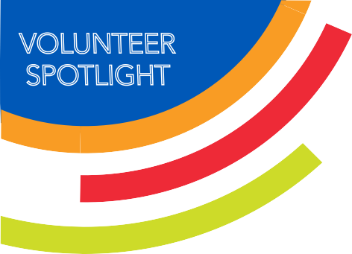
First Presbyterian Church
DONOR SPOTLIGHT

We are so grateful for the support from the congregation of First Presbyterian Church in Fort Collins. Their partnership with Project Self-Sufficiency began around 2002 when church member Tom Tonoli joined our Board of Directors. They began by providing about 50 food boxes for our families at Easter and Christmas. After several years, their Emergency Assistance Committee reassessed the food box donations, and instead provided our families with grocery cards, giving them the ability to shop for what they needed themselves. Through Tom, who served on our Board for six years, including a year as President, we also became financial beneficiaries. Even after Tom’s tenure on the Board ended, our partnership continued, and has grown substantially.
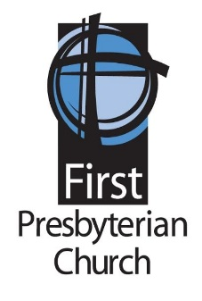
Through the Mission and Outreach Committee, we now receive a monthly donation. Through the generosity of the congregation over all these years, we have received over $44,000 in monetary contributions.

Church Deacons, Steve Breckenridge, and Brian Gandy explained that weeks before the holidays occur, the Emergency Assistance Committee makes a special donation request to members, via newsletter and video, explaining how the money is spent and describing our organization and what services we provide to our families. Included with the gift cards is a letter inviting Participants to visit the church with their children. Thus far over $41,000 in in-kind gifts, such as food baskets and grocery cards, have been distributed to our single-parent families.
We are humbled by the generosity the First Presbyterian family has shown to our families and are so grateful for our long-standing partnership!

Welcome New Members of Team Awesome!

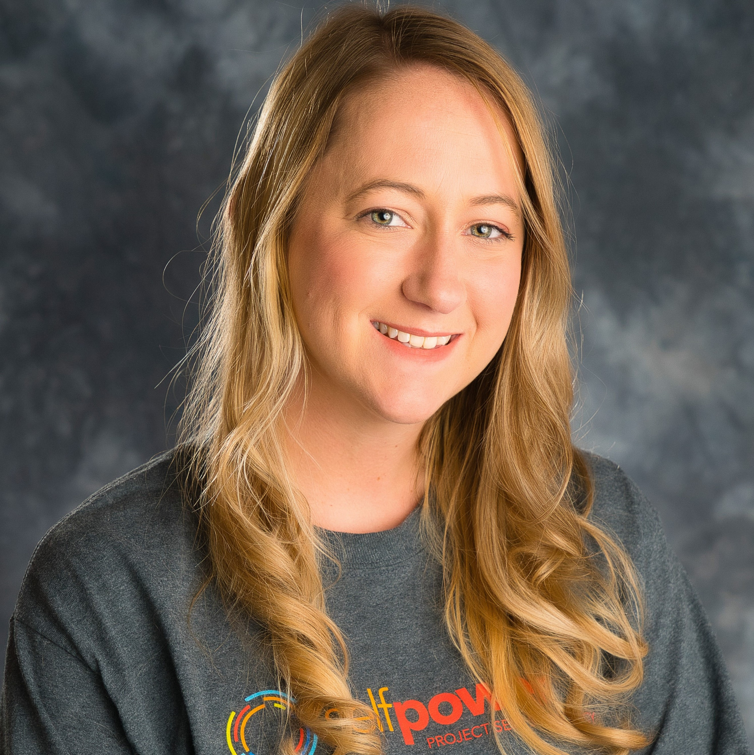
Robin Adams received her Master’s degree in Vocational Rehabilitation Counseling from the University of Northern Colorado in 2014 with a background in career counseling and advisement. Robin loves to partner with people to achieve their goals and use their selfpower to reach their full potential as a Program Advisor.

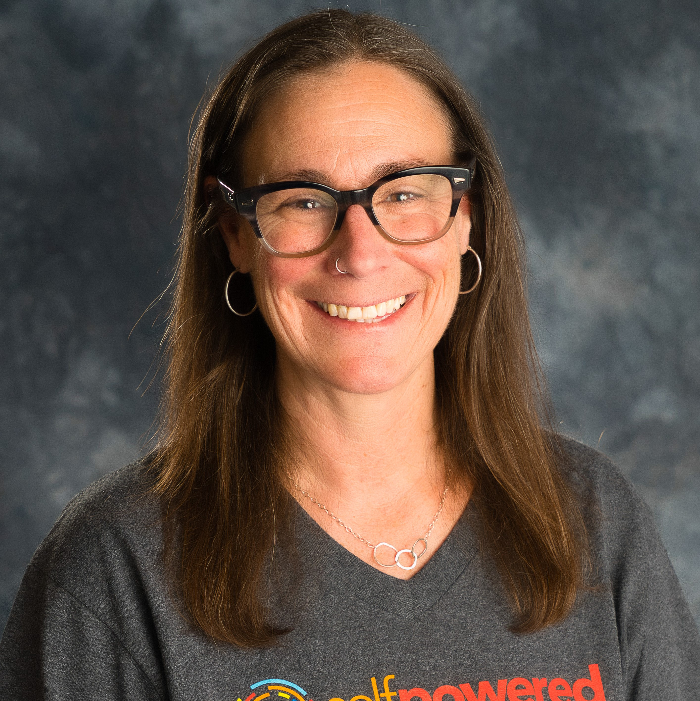
Stephanie Alley has a seven-year history of helping low-income parents realize their selfpower at Neighbor to Neighbor. She received her Bachelors of Social Work at Colorado State University after being a stay-at-home mom. Project Self-Sufficiency's mission and vision are the reason Stephanie joined the team and is delighted to serve our participants as a Program Advisor.

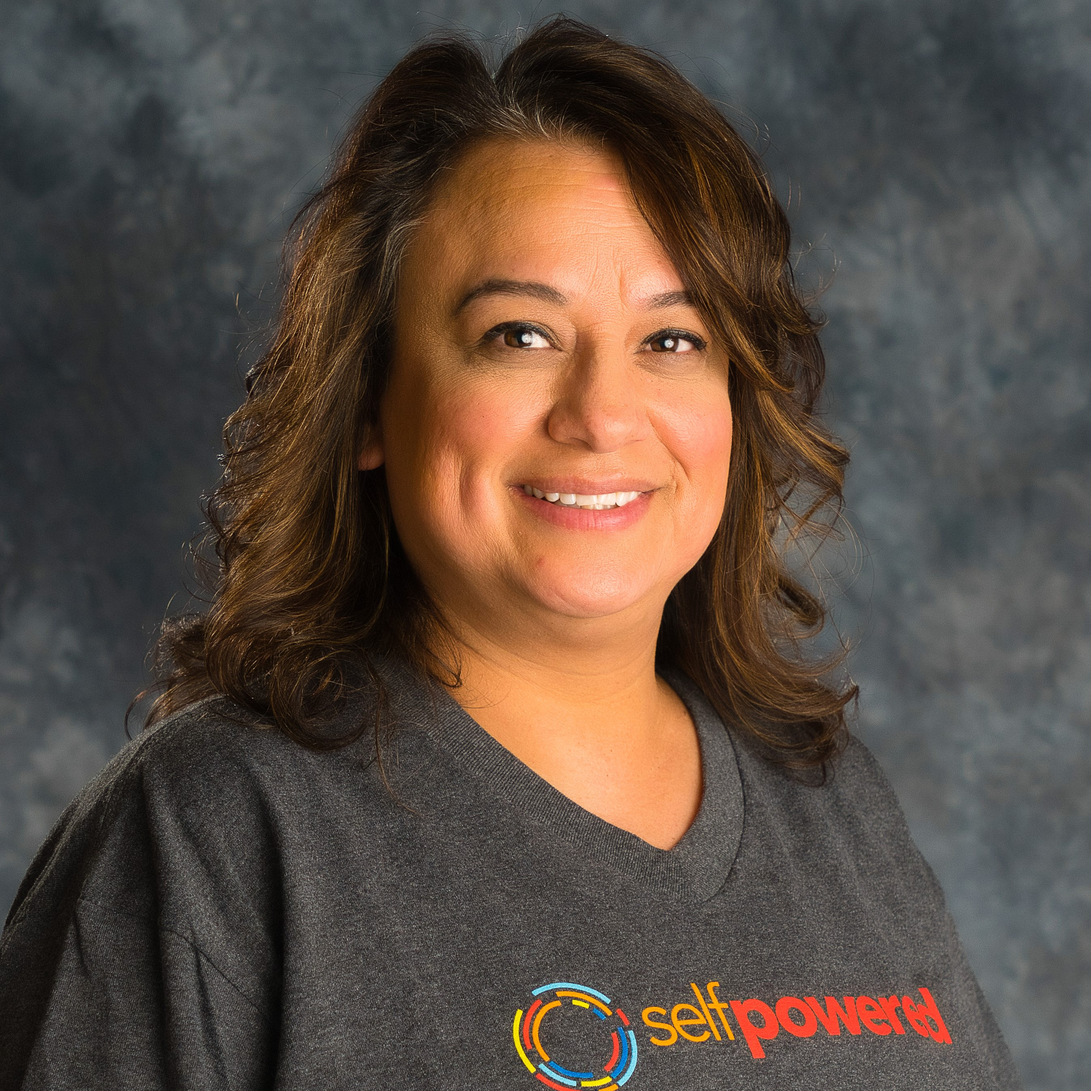
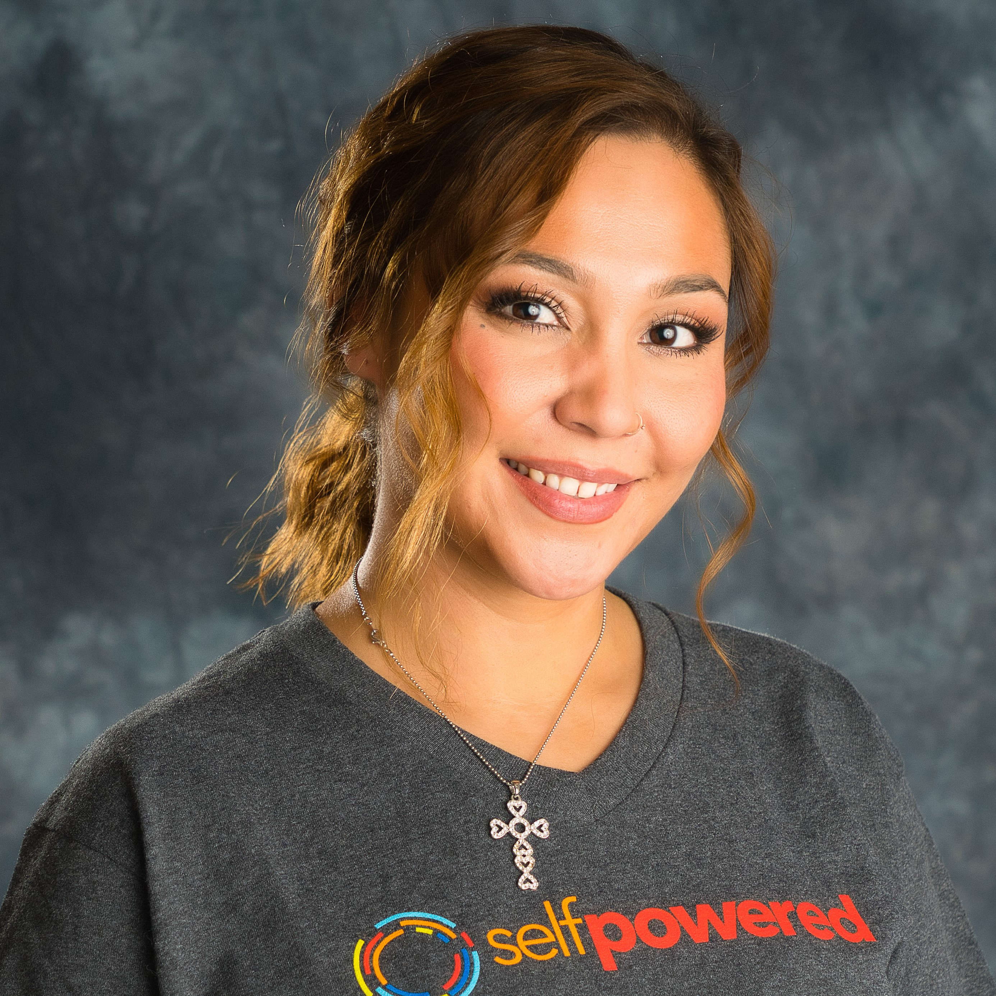
Naomi Salazar was born and raised in Weld County and has worked in Larimer County since 2005. She received her degree in Criminal Justice in 2005 as single mom of three boys. She has always had a passion to serve others in her community and is thrilled that she gets to continue that passion as a Program Advisor with Project Self-Sufficiency. She understands first-hand, the struggles and barriers that arise when working toward a higher education as a single parent and what it takes to grasp her selfpower.
Natasia Lovato Garcia is a Project Self-Sufficiency Graduate who earned her Bachelor’s Degree Human Development & Family Studies with a concentration in Prevention & Intervention Sciences at CSU. She worked in several different roles in the non-profit sector in Larimer County since 2013. She is happy that she gets to combine her passion, experience and her own selfpower to an advanced career with our organization as our Program Coordinator.
Welcome to Our Newest Board Members!
BOARD SPOTLIGHT
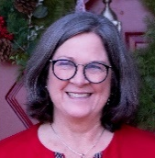
Cathy Hager
Before retiring from Corporate Accounting and Finance to raise her sons, Cathy acted as Assistant Controller and Financial Accounting Manager in companies ranging from High Technology to Food Production and Distribution.
For the past 20 years, her volunteer work in Fort Collins has allowed her to contribute to her community and further develop her supervisory and accounting skills. Cathy was a member of the School Accountability Committees, aided classroom teachers and worked with school Robotic competitions, both supervising students and managing finances. She has a B.S. in Business Administration from CU and a Master’s in Counseling Psychology from Notre Dame de Namur University.

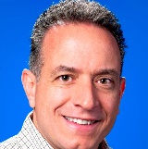
Chris Serafin
Chris grew up near Toronto, Canada. With a Finance degree and working initially with PPG Industries, Chris first worked internationally then eventually settled in the United States. After he and Jane married in 1995, they moved between Pittsburgh and Detroit twice in eight years while he earned his MBA from the University of Michigan. With two young daughters, Allie and Natalie, they came to Fort Collins in 2005 joining Hach Company/Danaher where Chris held various senior management positions.
Wishing to give back to the community after retiring from Hach at the end of 2020, Chris built upon his work with Hach Helps, a philanthropic strategy he developed there in 2010 bringing the Hach expertise to community partners such as the United Way and Boys & Girls Club. The mission and vision of Project Self-Sufficiency resonated with Chris, and he began his hands-on experience with the program by tutoring several program participants in statistics, accounting, and marketing classes at Front Range Community College. He then joined the Project Self-Sufficiency Board of Directors and serves on the Finance and Office Relocation Committees.

Farewell to these wonderful outgoing Board members:
Kerrie Luginbill, Chief Strategy Officer, Old Town Media, Inc.
Kerrie served as Board President and Chair of our Donor Relations Committee.
Her strong leadership and public relations brought strategy and creativity to our
organization's marketing and communications.
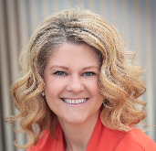
Erin Moomey, Broker Associate. Elevations Real Estate
With a career in real estate, Erin has been particularly passionate about solving housing challenges for our families. She worked to design a housing pilot and served on our Board Development Committee.
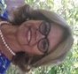

Dr. Guadalupe Salazar, Retired, Director, El Centro, Colorado State University
Dr. Salazar leveraged her experience and CSU connections to bring resources
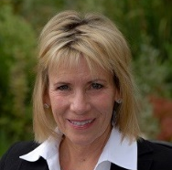
to Participants and guidance to our work with first-generation students.

Patti Stevenson, Retired healthcare executive
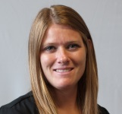
Patti shared her passion for our work with donors and strengthened Board and staff relations by serving on the Board-Staff Interaction Committee.

Nicole Walters, CPA. Soukup, Bush & Associates CPAs, P.C.
As a CPS, Nicole was a key member of our Finance Committee
and shared her accounting expertise and financial best practices.

Thank you for your time, talent, and treasure.

POWERFUL TIMES
Page 6

